Directions for the Simple Arachne website


http://minerva05.fnal.gov:8080/tagg/Arachne/simple.html

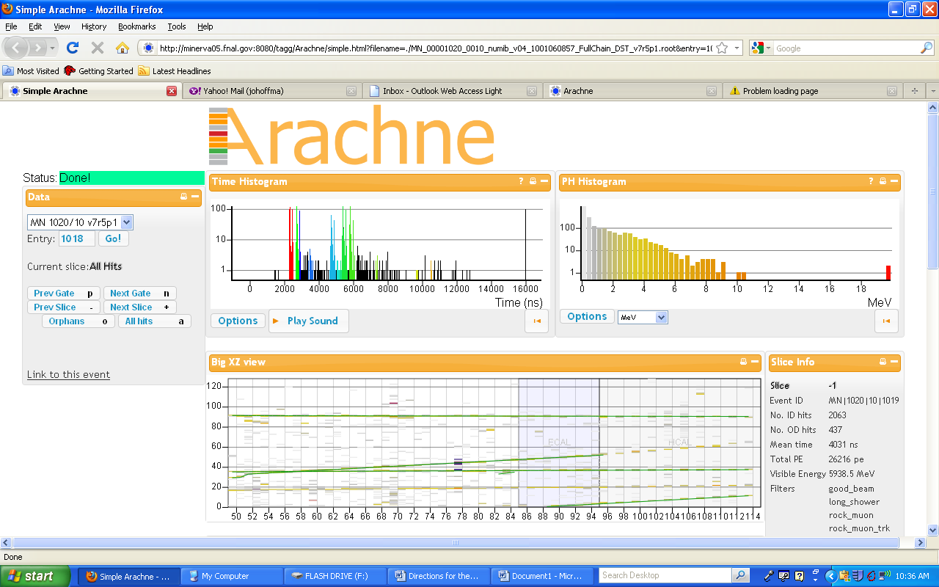
DATA:
- (example) MN 1020/10 v7r5p1 – represents the run and Sub-Run number of the event
- Entry – This is16000 ns of time in which a ‘snap-shot picture of the event was captured
- Prev/Next Gate – this changes the event viewed through the detector during a different 16000 ns of time and corresponds to the Entry #
- Prev/Next Slice – this gives you a specific time of the event within the given 16000 ns gate

[Analogy: the Run is like a roll of film…the Entry (Gate) is each individual picture on the film… the Slice contains the details within each picture]

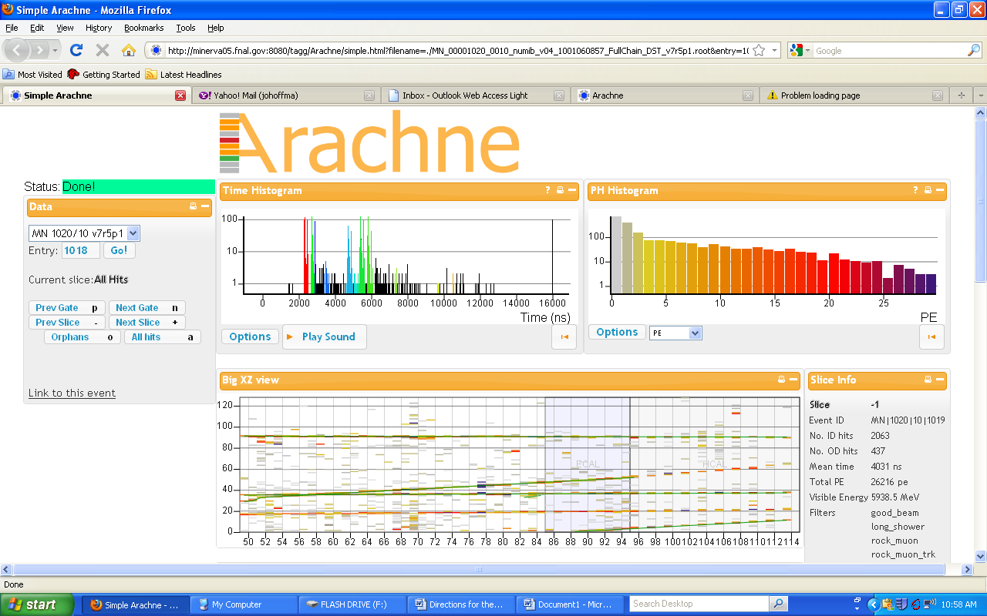
TIME HISTOGRAM:
- Gives you the indication of time (in ns) where informative events may have occurred. A grey highlighted curser moves across the histogram as you change Slices.
- The y-axis is measured Energy in MeV or in Photoelectrons (PE)

PH HISTOGRAM:
- PH stands for Pulse Height and is indicative to the energy (y-axis) deposited in the detector as the particles move through
- The energy levels can be displayed in different units (see Options) such as PE and MeV
- A value of 100 or greater indicates a useful event

BIG XZ VIEW:
- This area gives you the ‘picture of the event’ in which we will look for the presence of a muon, proton or electron moving through the modules of the detector
- The x-axis is the numbered modules that the particle is being detected in.
- The y-axis is scintillator strip number found within the modules. The distance between the centers of adjacent triangles is 1.6 cm
- The magnifier can be held over the tracks to get a clearer view of the energy changes detected. Blue signifies the highest change in energy.
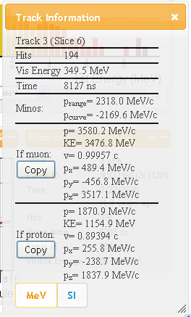
- ECAL and HCAL windows: Electronic Calorimeter and Hadronic Calorimeter are used as absorbers to stop particles by putting more material (lead and steel, respectively) in the particle’s way.

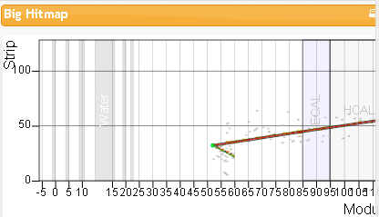
MAGNIFIER WINDOW:

MAGNIFIER WINDOW:
- When the cursor is held over the green path line, the path line will become red. Clicking the left mouse key will produce the window shown.
- This drop down menu allows you to see details about the particle.
- Track # - each green path is assigned a number
- Time – time in ns of the event
- Minos – the momentum of the particle (most likely a muon) in the ‘front face’ of the Minos detector at Fermi lab
- If Muon /If Proton – momentum and KE data of the proton and muon are used to determine the momentum and KE of the original neutrino and neutron prior to the collision. The proton’s path will be shorter, with more energy deposited in a short distance, and the muon’s path will reach beyond the detector, since it loses little energy as it travels. (See 3D display). This information is helpful when determining if the track is that of a proton or muon so that the correct data is recorded. By clicking on the Copy button, the needed information will be copied into an excel document for analysis

HIT MAPS:
- Detector views the event, as seen in the Big XZ view, but from different angles

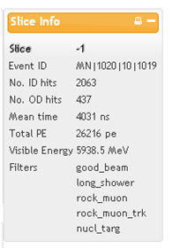
SLICE INFO:
- Mean Time - (Average) time for the event in that slice. Comparison of the mean time (of a muon path) in one slice to the mean time of the presence of the electron in a different slice is indicative to how long it takes the muon to decay
- No. ID hits – # of hits inside the detector
- No. OD hits - # of hits outside the detector
- Visible Energy – used to determine conservation of momentum and energy during muon decay. By measuring the visible energy during different slices, the amount of energy transferred from the muon to the electron can be determined.

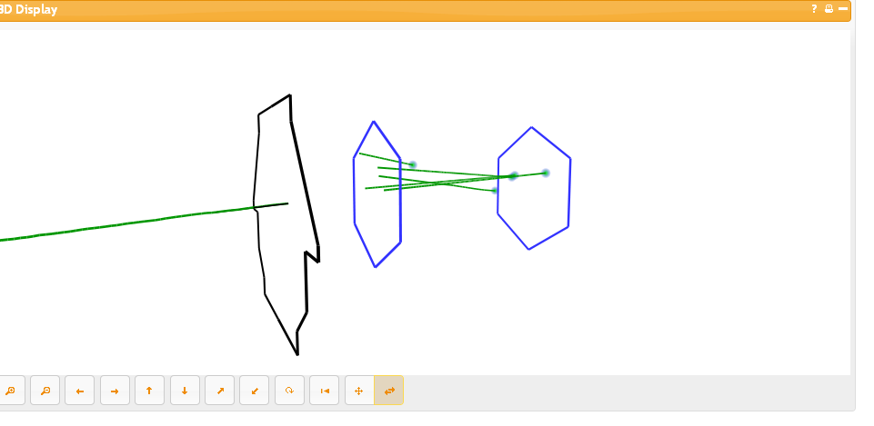
3D DISPLAY:
- This area shows a moving 3-
dimensional view of the
particles’ paths through the
detector
Muon

- The 2 hexagonal structures represent the front and back of the MINERvA (Main Injector Neutrino ExpeRiment v-A) detector. The particles’ paths are depicted by the lines starting with the dot (toward the right side of the diagram) and proceeding to the end of the detector (toward the left side.
MINOS ‘front face’
- The structure to the far left is the front face of the MINOS (Main Injector Neutrino Oscillation
Search) detector. The MINOS detector is also involved with neutrino detection and is part of an experiment that spans from Fermi lab to Tower Soudan Underground Physics Laboratory in Soudan, Minnesota
- If a particle extends beyond the end of the MINERvA detectors and enters in MINOS, than it is most likely a muon particle.

